Answers
1. Dorset Hotels is a website that offers hotel accommodation.
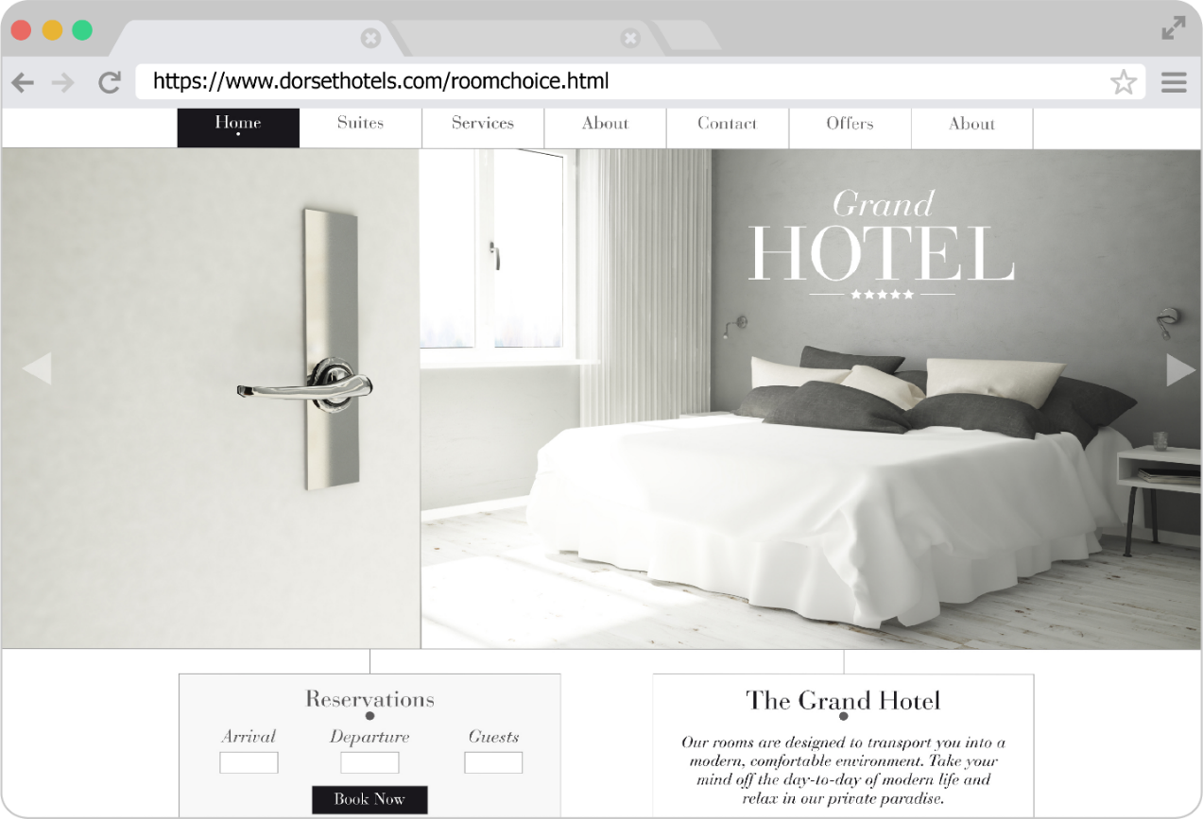
(a) The web page that is requested is located on the World Wide Web.
State the difference between the World Wide Web and the Internet. [1]
The World Wide Web is a service that makes use of the Internet (infrastructure) (1).
(b) State the domain name of the web page that has been requested. [1]
dorsethotels.com (1)
OR
DORSETHOTELS.COM (1)
Do not accept www.dorsethotels.com, this is the sub-domain or hostname.
(c) Describe the purpose of HTTPS for this web page request. [2]
This specifies the protocol used to deliver the page (1) as being Hypertext Transfer Protocol Secure (1). It ensures that communications (between the web server and client/browser) are encrypted (1). This protects personal information (such as credit card details that may be entered). (1)
(d) The main purpose of a web browser is to render and display web pages. Web browsers also store cookies they receive. State three other functions of web browsers. [3]
Storing bookmarks / favourites (1).
Recording user history (1).
Allowing use of multiple tabs (1).
Providing navigation tools / back and forward buttons / refresh button (1).
Providing an address bar (1).

(e) Dorset Hotels makes use of cookies. One reason for this is to remember users so that they don’t need to repeatedly login.
State one other reason that Dorset Hotels might use cookies. [1]
Saving personal details (1).
Tracking user preferences (1).
Holding booking details (1).
Holding rooms booked in an online shopping cart (1).
Accept other reasonable uses for this type of website.
Do not accept storing login details as this is part of the question.
(f) When a user logs in, the website makes use of a persistent cookie. Explain one reason why the website developer has chosen a persistent cookie rather than a session cookie. [2]
The persistent cookie is stored on the computer (until an expiry date) (1) so the user will remain logged in even if the browser is closed / computer is turned off (1).
OR
If they had used a session cookie, this would be deleted as soon as the browser is closed / computer is turned off (1) this would require the user to log in every time they visited the website (1).
(g) Dorset Hotels has started to accept a digital currency as payment for hotel rooms. Explain the purpose of a blockchain as part of these payments. [2]
The blockchain will be used to track currency transactions / store transactions on a digital/distributed ledger / keeps transactions as a time-stamped series of records (1) that cannot be altered / that prevents fraud (1).
(h) State the language that will be used to markup each webpage on the website. [1]
HTML / Hypertext Markup Language (1)
(i) Describe the role of DNS in retrieving the web page. [3]
The browser sends the domain name to the DNS server / Domain Name System server (1) which looks it up to find the corresponding IP address (1). The IP address is then sent back to the browser (1). The web page request is then sent to the correct IP address (1) that contains the web server (1).
2. Freddie has a new laptop which he connects to his home network to access the Internet.
(a) State the device that Freddie connects to. [1]
Router. (1)
Accept switch / hub / wireless access point / WAP.
(b) Freddie’s laptop is allocated the number 192.168.1.7 when it connects to the home network.
State the type of address that is being used by his laptop. [1]
An Internet protocol / IP address / IPv4 address. (1)

(c) Freddie’s internet service provider (ISP) allocates a static IP address to his house.
Explain what is meant by a static IP address. [2]
The value of the IP address will be the same (1) even when the router reconnects / is turned off and on again (1) which is useful when trying to access the network from somewhere else on the Internet (1).
Freddie’s laptop states in the settings that it has the MAC address:
00:00:22:bc:ad:e2
(d) Explain the meaning of the term MAC address. [2]
It is the Media Access Control (1) address. It is a unique identifier (1) given to each network interface controller / NIC (1). It is used as the network address (as part of the data link layer) (1).
(e) State the two components that make up a MAC address. [2]
The manufacturer code (1).
The serial code / number (1).
In this example, 00:00:22 is the manufacturer code, bc:ad:e2 is the serial code.
(f) Give one role of a router in a network. [1]
It sends/routes data to/towards a specific destination (1).
It can assign IP addresses (assuming it contains a DHCP server) (1).
It connects a local network to the Internet (assuming it contains a copper/fibre modem) (1).
(g) Freddie’s network currently makes use of IPv4.
Give two differences that IPv6 has compared to IPv4. [2]
IPv6 makes use of 128-bit addresses / has a much larger address pool (1).
IPv6 addresses are written in hexadecimal / are eight groups of four hexadecimal digits (1).
IPv6 addresses separate each group of hexadecimal digits by colons (1).
IPv6 devices may connect automatically without the need for a DHCP server (1).
IPv6 is more secure than IPv4.
3. Aruna works as a technician in a university’s IT services department.
Three possible threats to the network are:
- Brute-force attacks
- Distributed denial of service (DDoS) attacks
- Malware such as viruses and worms.
(a) State one other type of malware. [1]
Trojan horse (1)
Spyware (1)
Adware (1)
Ransomware (1)
(b) Researchers at the university can only enter their office by entering a four-digit number into a keypad at the door.
Describe how a brute-force attack could be used to gain access to an office. [2]
Someone could try entering every possible number into the keypad / enter all the numbers from 0000 to 9999 (1) until the correct combination is entered (1).
(c) A number of people at the university have contacted Aruna to say that the network has significantly slowed down. Aruna has found that the cause of the problem is that the university is experiencing a distributed denial of service (DDoS) attack.
Describe the processes involved in a DDoS attack. [3]
In a denial-of-service attack, a target computer / server / router is sent a large number of irrelevant requests / flooded with requests (1). The targeted machine is unable to process all the requests (1). This leads to the machine becoming unavailable / significantly slow down (1). In a distributed denial of service, a large number of machines are involved in the attack (1).
(d) The university makes use of a proxy server. Explain the purpose of a proxy server. [2]
Requests to a server are first sent to a proxy server on the private network (1). The proxy server acts as a gateway between users and the Internet (1). This separates the private network from the Internet (1). The proxy server may cache recent web pages (1) which will increase access times if another user on the private network requests it (1).
(e) The university also makes use of access levels to improve the security of their system. Explain the restrictions that a researcher at the university is likely to experience on their files and computer services as a result of access levels.
Restrictions on files: [2]
Files / folders each have permissions applied to them (1). This allows the researcher to access their own files / files that are in a shared area with colleagues (1), but prevents them from accessing other user’s files / confidential files of other workgroups (1). This helps to keep research information/results confidential (1).
Restrictions on computer services: [2]
Services include access to printers / file servers / programs / software (1). Researchers will be restricted to only being allowed to use certain hardware / software (1). For instance, they may be restricted from accessing software that has a limited number of licences (1) or a printer that is part of a different department / office / building (1).
Accept other reasonable examples of restrictions on computer services.
(f) Give one other method that the university is likely to use to keep data safe from
security threats. [1]
Anti-malware / anti-virus / anti-spyware (1).
Authentication / usernames and passwords / biometrics / two-step verification (1).
Automating software updates (1).
Checking the spelling and tone of communications (1).
Checking the URL attached to a link (1).
Firewalls (1).
Privacy settings (1).
Secure socket layer / SSL (1).
[Total 40 Marks]

